IS 350—Professor Mark G. Simkin Creating a Valid Password

Objective: The objective of this assignment is to create a simple input screen that allows a user to create his or her password and to create code that validates this password. This assignment requires a good understanding of parsing techniques, For-Next loop constructs, the Chr function, user-defined functions, form-level variables, and programming logic.

Description: A computer system requires a user to create a password of the form AAAANN, where “A” is any alphabetic character (either uppercase or lowercase) and “N” is any numeric digit. An additional requirement is that the password contains both upper and lower case letters. A suggested user interface is shown below. When the user enters a password in the textboxes and clicks on the command button, the system performs the following tests: (1) matching non-blank entries, (2) a proper length of six characters, (3) first four digits are alphabetic, (4) last two digits are numeric, and (5) password has at least one uppercase and one lowercase letter. If the user’s entry violates any of these rules, the system provides an error message indicating the problem. Two examples of such messages are also shown below.

Hints: (1) You should test for a valid password length first, because short passwords cannot be parsed properly. (2) You may find it useful to create a user-defined function that tests for a single valid alphabetic character and that you can call repeatedly in your code. (3) The uppercase and lowercase letters can be accessed in Visual Basic using the Chr(x) function. (4) One way to test for the presence of both an uppercase and lowercase letter in the password is to use separate Boolean variables (e.g., “FoundUpper” and “FoundLower”) to represent a “found” conditions for each of them. If you initially set these variables to “false,” you can check later whether these variables were reset to “true” with your code. I’m sure there are other ways to accomplish these same tasks.

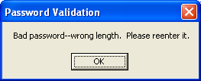
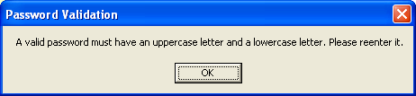
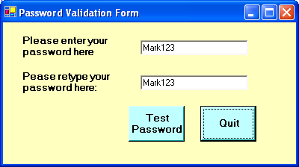

Deliverables: Screen-capture your user interface at run time and also print a copy of your code. Test your program with the following passwords: (1) MAR123, (2) MARK123, (3) Mark12, (4) Mark123, (5) mark123, (6) Mar123, (7) MArkXX, (8) 123MAR, (9) ZZZz12, and (10) passwords do not match in first and second text boxes. For full credit, screen-capture the resulting error message for each incorrect password.

